What’s Wrong With The God Equation?

Howard Bloom

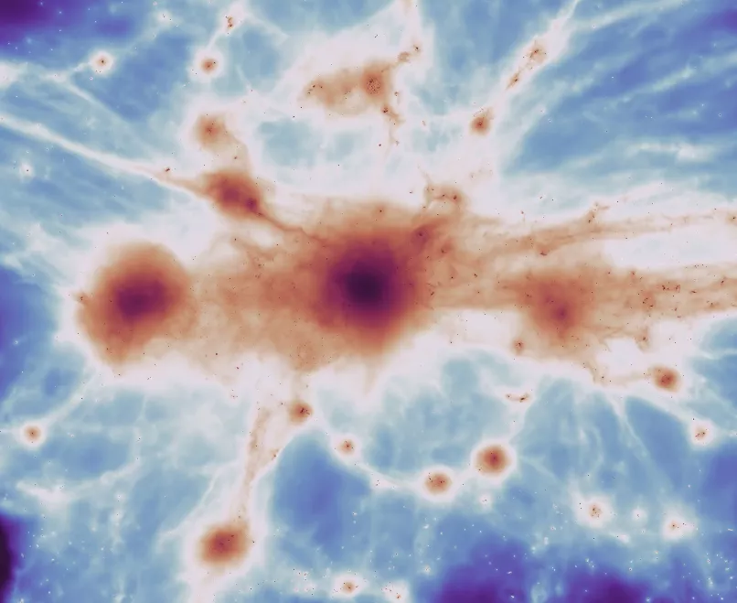

In the spring of 2021, the British magazine The New Scientist announced that Michio Kaku, a high-profile physicist from the City University of New York who has appeared on TV steadily over the last 40 years, would be giving a virtual lecture. Kaku was going to explain grand unified theories of everything. First, he was going to explain how Newton came up with laws of motion. Then he was going to show how over a hundred years and fifty years later, Maxwell worked out four equations that took Newton one step further and described what electromagnetism was. Finally, Kaku was going to explain how physicists today are trying to come up with an even more inclusive equation, an equation that describes the laws of the motion of matter, electromagnetism, and gravity. Says Kaku, physicists want an equation that you can put on a T-shirt. That to them will be “the grand unified theory of everything.” The GUT. In other words, physicists are looking for what Kaku’s new book title calls “The God Equation.”

But this Grand Unified Theory of Everything isn’t really what it pretends to be. There are vast levels of reality that this grand unified equation, this god equation, will never help us understand. The equation won’t give us insight into how life pulled itself together on a poisonous planet in a poisonous sea over 3.5 billion years ago. It won’t explain how an egg hatches into a chick. It won’t explain how we humans come together in clans, tribes, nations, and civilizations. It won’t help us understand the ecstasies we can experience when we are in love with each other, when we have sex and when we make love with each other. Or even the ecstasy at a rock concert.

The mass raptures that the equation will not capture utterly defy belief. When crowds have ecstasies, these ecstasies can be forces of history.

Look at Hitler....he was an artist of group ecstasies. He gave Germans the feeling of being a part of something far, far bigger than themselves. When he gathered the German people in crowds, he was able to evoke collective raptures. And those ecstatic experiences fueled the Germans to start a war of conquest—World War II. Ecstasies, things of the spirit, can power new realities. New realities in the material world.

Which means that we don’t just need a science that uses the atom smasher at CERN to look at things so small that even a microscope cannot see them. We don’t just need a grand unified equation that physicists can claim sums up everything. That god equation when it arrives will be important. But it will sum up almost nothing!

I have no idea of how this project landed on my plate, but since I was twelve years old my goal has been to put together the opposite of the atom smasher. My goal has been to assemble the opposite of the instrument that lets us break things down to their tiniest elements in order to understand everything. The tool I’ve been impelled to use has reached for the biggest picture possible, not the smallest. My tool has been the timeline of the cosmos. The history of the whole astonishing thing, of everything that ever was, so that you can see how the burst of the big bang and the birth of the first galaxies relates to the strange flickers of the human spirit in you and me.

The aim has been a Grand Unified Theory that puts physics, chemistry, biology, neuroscience, the evolution of human societies, poetry, the arts, and the strange emotions of the human mind into a single big picture, a grand panoramic vision, a real grand unified theory of everything. A theory that filmmaker David Van Taylor would someday take a look at and call The Grand Unified Theory of Everything in the Universe Including Sex, Violence, and The Human Soul.

You could say that instead of using a microscope or a telescope, this Grand Unified Theory has used an omniscope.

Howard Bloom has been called the Einstein, Newton, Darwin and Freud of the 21st century by England’s Channel4 TV. His most recent book is Einstein, Michael Jackson & Me: a Search for Soul in the Power Pits of Rock and Roll (Rowman & Littlefield).